WEBEX FAQ’S - Hosting, Joining, and Setting up Meetings

This page contains the most frequently-asked questions about how to host, setup, and join Webex Meeting Center. For detailed information and instructions, please visit our Webex Meetings – Documentation and Job Aid Library.

Q. What do I need to host or attend meetings?

A. Hosts will need a license, available from Related’s Help Desk. The Help Desk will install the Cisco Webex Meetings Desktop application and configure the integration between the WebEx Meeting Manager and Microsoft Outlook.

Webex attendees do not need a license or special software to participate in meetings. Hosts will send attendees web links and telephone numbers to join. Meetings that include video sharing will occur over the internet.

Q. How can I schedule a WebEx meeting?

A. Hosts will have a Webex Schedule Meeting button on the Home ribbon of Outlook. Clicking this button will create an Outlook meeting invitation, and will embed the Webex meeting details. The attendees you invite can join your meeting directly from their Outlook calendars. This is the most efficient method for setting up meetings.

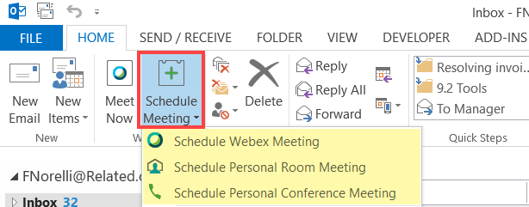

Hosts will also have the Cisco Webex Meetings Desktop application installed for scheduling and managing meetings, as well as configuring personal Webex preferences (i.e. pin and call back numbers).

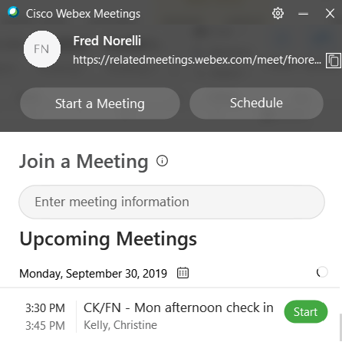

Q. What are the different types of meetings I can host?

A. Hosts have three types of meetings they can schedule:

The standard Scheduled Webex Meeting is the most traditional type of meeting. It is usually scheduled in advance, and when the meeting link is sent to the attendees it will always have a unique URL with an embedded password. Utilize this if your meeting includes external clients or vendors.

Your Personal Room Meeting is your very own conference space that you can use for meetings at any given time. The advantage is that the URL stays the same so you always know how to access your meeting space; you don’t have to book your meetings in advance. With just a click of the button you can schedule meetings on the fly.

Conference Center Meeting is an audio-only meeting when video collaboration is not needed. Attendees will still receive a link to the Webex meeting center, and can still log into the meeting site to use VoIP (internet) audio, but this type of meeting has no video capabilities or collaboration tools.

Q. How do I log into a Webex meeting?

A. If you receive a meeting request from a host via Outlook, it will contain meeting details such as meeting access code, telephone numbers, and either a link to the Webex meeting site or a large green Join button (depending on how the host setup the meeting). Simply click the link or the Join button embedded in the email. | 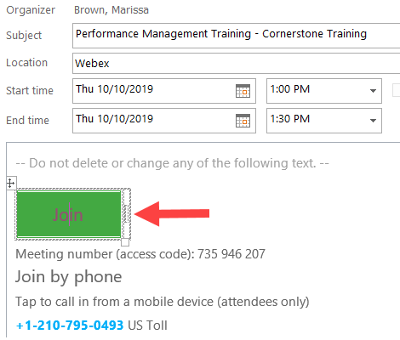

The Webex meeting internet site will open.

- If you are logged into the Related network simply click the Sign In button in the top-right corner of the page. Related employees are configured with SSO (single sign-on).

- If you are not a Related employee, or are not logged into the Related network, you will be required to enter your name and your email address to log into the meeting.

Q. What is the preferred call in method for the teleconference portion of a meeting?

A. For the teleconference portion of a meeting (audio), ‘internet audio’, also called voice over IP (VoIP), is optimal. For audio this is the most technologically and cost efficient method.

Other audio options include a toll number and a Call Me Back feature where you enter your telephone number and the system will call that number and connect you to the meeting.

If your meeting includes a toll free number (starting with 800 or 888) please do not utilize this number, as it is not cost effective for you nor your company. The future state of Related’s Webex offering will not include the toll free option.

